Create a table named: emp_dept

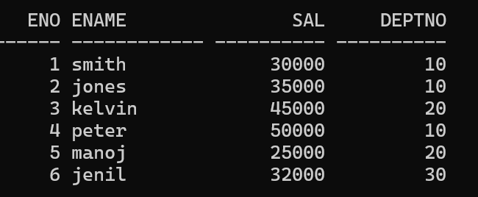

Perform given Queries:

1. Calculate sum of salaries of all employees.
2. Calculate average of salaries of all employees.
3. Count total number of employees working in all departments.
4. Find out the minimum salary of each department.
5. Count total number of employees working in each department.
6. Find out those department who are having only three employees.
7. Find out those departments who are having greater than 10000 average salaries.